Proposal for Riget Zoo Adventures (RZA)

Contents

Business context.............................................................................................................................................2

SWOT Analysis.............................................................................................................................................2

Empathy map..............................................................................................................................................2

User stories.................................................................................................................................................2

Functional Requirements................................................................................................................................4

Homepage...............................................................................................................................................4

Educational visits page............................................................................................................................4

Booking system.......................................................................................................................................4

Personal Account....................................................................................................................................5

Non-functional Requirements ........................................................................................................................5

Security ...................................................................................................................................................5

Maintainability........................................................................................................................................5

Performance ...........................................................................................................................................5

Usability -> Accessibility..........................................................................................................................5

Decomposition................................................................................................................................................6

KPI’s.................................................................................................................................................................6

Business KPI’s..........................................................................................................................................6

Website KPI’s..........................................................................................................................................7

A description of proposed solution ................................................................................................................8

Justification.....................................................................................................................................................8

How the recommended solution meets the needs of the client................................................................9

How protentional risks will be mitigated..................................................................................................10

Regulatory guidelines and legal requirements will be addressed. ...........................................................11

Appendix 1 ....................................................................................................................................................13

Hardware and software ............................................................................................................................13

Emerging technologies..............................................................................................................................14

Meeting different user needs...................................................................................................................16

Guidelines and Regulations ......................................................................................................................25

Appendix 2 ....................................................................................................................................................26

Business context

Riget Zoo Adventures is a wildlife park and tourist attraction aiming to provide an educational and engaging experience for visitors, focusing on animal conservation and sustainable tourism. The zoo attracts many local and international visitors annually and is looking to enhance their visitor experience, improve operational efficiency, and increase customer engagement using digital technologies.

SWOT analysis

**Strengths**:

* Engaging Content: The website offers a variety of interactive and educational content, such as animal facts, videos, virtual tours, and conservation information.
* User-Friendly Design: The website is easy to navigate, with a clear layout that allows visitors to quickly find information about ticketing, exhibits, events, and more.
* Online Ticket Sales: Convenient online ticketing system that helps reduce long lines and offers special discounts or promotions.
* Community Engagement: Provides opportunities for users to donate, adopt animals, and participate in community events, fostering a sense of involvement and support.

**Weaknesses**:

* Limited Accessibility Features: The website may not fully cater to people with disabilities (e.g., lack of screen reader compatibility or language options).
* Lack of Multi-Language Support: The site may only be available in one language, limiting accessibility for international audiences.
* Slow Load Times: Some pages or high-quality media may take longer to load, which could frustrate users and drive them away.
* Inadequate Search Functionality: The search bar may not always yield the most relevant results, making it harder for users to find specific information.

**Opportunities**:

* Virtual Animal Encounters: Expand virtual zoo experiences like live-streamed animal feeds, behind-the-scenes tours, or interactive Q&A with zookeepers, which could attract more global visitors.
* Increased Focus on Conservation: Highlighting the zoo's conservation efforts through blog posts, videos, and donation opportunities could resonate with eco-conscious visitors and increase support.
* Partnerships with Schools: Creating educational resources and programs for schools could lead to increased traffic, both from teachers and students.
* E-commerce Opportunities: Adding an online store with zoo-themed merchandise or even tickets and memberships could create an additional revenue stream.
* Enhanced Social Media Integration: Integrating live social media feeds or user-generated content (e.g., visitors' photos and reviews) on the website could increase engagement and drive traffic.

**Threats**:

* Competition from Other Attractions: Other family-friendly attractions (museums, aquariums, theme parks) may have better marketing or offers, drawing attention away from the zoo.
* Economic Factors: Economic downturns or changes in disposable income may reduce overall visitorship to the zoo, affecting both online and on-site engagement.
* Technology Issues: Technical glitches or outdated infrastructure could result in downtime, leading to poor user experience or loss of potential ticket sales.
* Environmental or Animal Welfare Concerns: Negative press regarding animal welfare or environmental impact could harm the zoo's reputation and online image.
* Security Risks: Data breaches or security vulnerabilities, especially in online transactions, could damage user trust and the zoo’s credibility.

Empathy map

**1. Says**

What users say about their experience or expectations:

-"I want to learn more about animals before visiting."

-"I need to buy tickets online to avoid long queues."

-"I’d love to see live animal cams or virtual tours."

-"How do I donate to the zoo?"

-"I need to know the zoo’s opening hours and special events."

**2. Thinks**

What users think while using the website:

-"Is this website easy to navigate?"

-"Are the prices fair for tickets and memberships?"

-"I hope I can find clear information about animal welfare and conservation efforts."

-"Will I get a good experience for my kids?"

-"I wonder if I can find any discounts or special promotions."

**3. Does**

What users do on the website:

-Browse through the list of animals and exhibits.

-Search for ticket prices and opening hours.

-Check for educational content or events related to conservation.

-Look for ways to donate or adopt an animal.

-Share the website or specific animal info on social media.

-Purchase tickets or memberships online.

**4. Feels**

What users feel when interacting with the website:

-Excited to see animals and exhibits.

-Curious about animal behaviour or fun facts.

-Frustrated if the website is slow or hard to navigate.

-Confused if information is scattered or unclear (like event schedules or ticket pricing).

-Happy when they find a simple way to donate or get involved.

-Satisfied when the website is user-friendly and provides the right information quickly.

User stories

***User story 1***

**Stakeholder type**: Owner

**Name**: Michael Scott

**Age**: 35

**Characteristics**:

- Stern

- Loves animals

- Friendly

- Extrovert

- Rich

**User story**:

I am the owner of the zoo, every now and then I go around the zoo and interact with the customers to check they are enjoying themselves.

I also like to feed and care for the animals, so usually some of the staff have a little extra break.

I am fairly lenient with my staff, but I won’t have them messing around if stuff still needs to be done.

**Use of services**:

- Checking people are having fun

- Interacting with staff

- Feeding and caring for animals

- Admin work on the website

***User story 2***

**Stakeholder type**: Staff

**Name**: John Smith

**Age**: 25

**Characteristics**:

- Confident

- Likes to go out

- Extrovert

- Easy going

**User story**:

I am working at the zoo, I enjoy the zoo, it’s nice to walk around.

Its large and high quality, so it keeps me occupied.

I am a bit strapped for cash at the moment, it pays well, especially since you get a discount for any services at the zoo.

**Use of services**:

- Using website to use discounts on tickets

- Checking map of zoo

- Staff work on the website, if needed

- Helping customers

***User Story 3***

**Stakeholder type**: Educational

**Name**: Walter Richard

**Age**: 69

**Characteristics**:

- Careful

- Not a risk taker

- Positive

**User story**:

I am checking out if this zoo is suitable for an educational trip for my students.

I’m hoping this zoo is kid friendly, however I am worried it will be too large and they will get bored too fast.

The cafe should be good quality, I want the kids to have good food if they are buying some.

**Use of services**:

- Booking tickets on website

- Checking map of zoo on website

- Eating at zoo cafe

- Needs quick paths to exit zoo if needed

***User Story 4***

**Stakeholder type**: Customer

**Name**: Michael Scott Jr.

**Age**: 15

**Characteristics**:

- Hyperactive

- Introvert

- Reluctant to spend money

- Friendly

**User story**:

I am going on a trip to the zoo with my friends.

I’m going to get out of cleaning the house, I want the zoo to be big enough to walk around for a while.

I’ve got money for the gift shop; I’m going to buy some fun things.

**Use of services**:

- Checking all the exhibits online

- Using a map of the zoo

- Eating packed lunch at cafe

- Buying things at the gift shop

Functional Requirements

Website Integration

- Users can view exhibit information, schedules, events, and purchase tickets through the - website  
- A map feature to help visitors navigate the zoo  
- A personalised user experience, allowing families or groups to create a custom itinerary for their visit  
- Integration with an online payment system for easy ticket purchasing, event bookings, and donations

Ticketing Management

- The system should enable online booking for tickets, loyalty rewards, and features for repeat visitors

Educational visits page

The system features an educational visit page that includes a navigation bar and a main section where users can browse a catalogue of useful materials for their trip and view pricing details. No data input is required for this page.

Booking system

The system should let users create an account or sign in if they already have one. Once logged in, users should be able to manage their bookings, such as cancelling reservations, viewing past stays, and checking rewards. The system should also provide an option to log out when needed.

Non-functional Requirements

Security

**System Security and Robustness**

The system must validate all data inputs.

Passwords must be encrypted.

Maintainability

**Cost-effective System Maintenance**

After deployment, it is crucial that the system remains cost-effective to maintain. To ensure this, I will adhere to best coding practices, ensure that naming conventions are clear and logical, and use only standard API formats throughout the code.

Performance

**Page Speed/Load**

The webpage should load within 2 to 6 seconds.

Usability and Accessibility

The system should be easy to use for both visitors and content editors. It should also meet different user needs by following Web Content Accessibility (WCAG) guidelines.

Decomposition

**User Navigation and Experience**  
Problem: Visitors may find it challenging to navigate the zoo efficiently, especially during peak seasons  
Solution: Develop a GPS-based navigation feature integrated with the app to guide visitors through the zoo in real time.

**Ticketing and Booking System**  
Problem: Managing high visitor traffic can lead to delays in ticket purchases and long queues  
Solution: Implement an online ticketing system with fast checkout and real-time availability to streamline the purchasing process.

**Data Security**  
Problem: Ensuring the secure handling of customer data (personal and financial)  
Solution: Integrate robust encryption and security protocols to protect user data and meet regulatory standards like GDPR.

**User Engagement**  
Problem: Visitors may not fully engage with educational content or stay interested throughout their visit.  
Solution: Use AR and interactive elements to enhance engagement and learning, such as animal exhibits coming to life through the app.

**Performance during high traffic**

Problem: The system may experience slowdowns during peak visitor times, especially with real-time notifications and ticketing  
Solution: Optimize back-end infrastructure for scalability and use cloud solutions for load balancing.

KPI’s

Business KPI’s

**Conversion Rate** – Tracks purchases of tickets directly impacting revenue.  
**Customer Satisfaction (CSAT)** – Measures visitor experience, crucial for business success.  
**App Retention Rate** – Indicates customer loyalty and long-term business value.

Website KPI’s

**User Engagement Rate** – Measures how often users interact with app features.  
**Peak Traffic Handling** – Evaluates system performance under high load, affecting usability.

User Acceptance Criteria (UAC)

- The app should load within 3 seconds and provide clear instructions for navigation  
- All features (ticketing, navigation, educational tools) should work seamlessly with no crashes  
- The booking system should allow quick and easy access to tickets with a secure payment gateway

A description of proposed solution

The proposed digital solution is a **website integration** that enhances the visitor experience at Riget Zoo Adventures. The website will feature an online ticketing system, interactive educational content to make the zoo visit more engaging.

Key features:  
**Zoo Navigation** - Interactive maps, and real-time alerts about events and feeding times.

**Ticketing System** - Seamless booking experience for tickets, and event reservations with secure payment options.

**Educational Tools** - Interactive features for visitors of all ages.

**Information pages** - Will provide customers with information about the zoo and facilities, opening times, hotel, and animals.

Justification

How the recommended solution meets the needs of the client

For Riget Zoo Adventures The solution will drive more foot traffic and revenue through seamless online ticketing, loyalty programs, and customer engagement. It helps the zoo stand out by offering a unique, interactive visitor experience.

A key client requirement is enabling users to book tickets and hotel rooms online effortlessly. The website will feature an intuitive booking system supported by a strong backend and database, allowing the client to efficiently track ticket sales and room reservations. This data will provide valuable insights, helping the client make well-informed strategic and technical decisions. Additionally, customer satisfaction will improve as guests can avoid long queues and secure their bookings without worrying about room availability.

To support educational visits, a separate page will be created specifically for educational trips, displaying all essential information in one place. This dedicated section will be easily accessible from the navigation bar, ensuring a seamless user experience. By making relevant details readily available, the page will enhance the overall experience for students and educators alike.

How protentional risks will be mitigated

**Secure Payments – Data Encryption**

Security Risks Data encryption and secure payment systems will ensure compliance with privacy laws (e.g., GDPR)  
Performance Issues Scalable cloud infrastructure ensures the system can handle high traffic volumes  
User Adoption User testing and regular feedback collection will help refine the app and ensure it meets visitor expectations.

**Booking System - Data Loss**

The booking system comes with several potential risks, such as overcomplicating the process, lacking sufficient customer support, or failing to customize it to meet business needs. However, the main concern here is system glitches and data loss, which could severely damage the business's reputation. For instance, if a data loss occurs and customers who booked a hotel are left without accommodations, it would be an extremely frustrating experience for them, forcing them to find alternative arrangements on the day of their visit.

To address this, the system must undergo thorough testing. Additionally, data loss may not always be fully preventable, so implementing regular data backups will be an effective way to minimize this risk.

**Personalized Account - Data Breaches**

One of the most significant risks is a data breach. Since the login system involves gathering customer information, there is always the possibility of this data being stolen. To mitigate this risk, the company should implement a comprehensive security plan that includes various preventive measures. In this context, I will be implementing password encryption to strengthen the overall security of the system.

Regulatory guidelines and legal requirements will be addressed

GDPR Compliance The app will adhere to data protection regulations, ensuring the secure collection and handling of personal data  
Accessibility Standards The app and website will meet WCAG guidelines, making it usable for visitors with disabilities  
Tourism Regulations The app will comply with local tourism and business regulations, ensuring it aligns with industry standards and best practices.

Appendix 1

Hardware and software

**Contactless payment**

One of the most significant advancements is the rise of contactless payments. Additionally, customers may not always have their credit or debit cards with them or immediate access to cash. Offering cashless transactions enhances accessibility, as most people carry smartphones, while also streamlining the process, saving time and effort for both customers and employees.

**Voice control**

Integrating voice control and voice search features is a major leap toward enhancing accessibility in the travel industry. Many apps were previously inaccessible to individuals with visual impairments, but voice-enabled functionality opens the door to a wider audience. Beyond improving the booking experience, voice controls can make travel more interactive and engaging.

Emerging technologies

**Augmented Reality (AR) for Enhanced Travel Experiences**

To stay competitive, travel and tourism companies must embrace augmented reality (AR) as a key part of the customer experience. The AR market is expected to grow emphasizing its rising significance in the industry. This rapid expansion highlights AR’s crucial role in boosting customer engagement while giving businesses a competitive advantage in the travel and tourism sector.

**Interactive Maps**

In today’s interconnected world, advanced mapping software has become essential, transforming how we navigate and interact with our surroundings. By 2025, mapping technology has evolved beyond simple directional guidance, offering businesses and users a more immersive and dynamic experience. These interactive solutions integrate real-time data, satellite imagery, and machine learning algorithms to deliver highly accurate, up-to-date maps.

Meeting different user needs

A clear and easy to navigate website, adapted so children can look through it as well. The

examples that I have researched are London Zoo, Chester Zoo and Marwell Zoo.

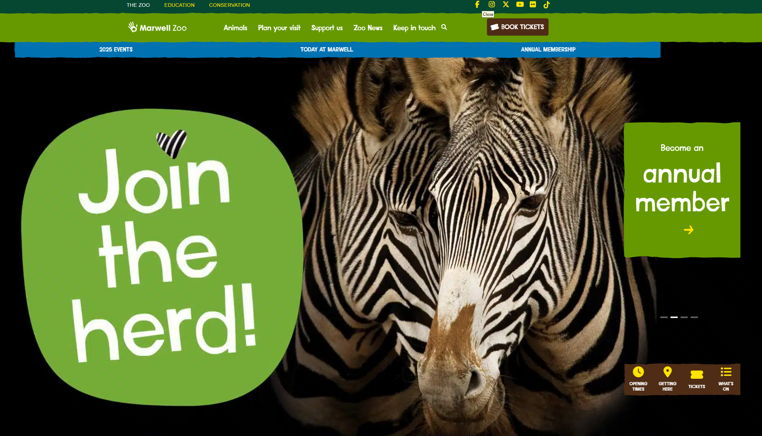

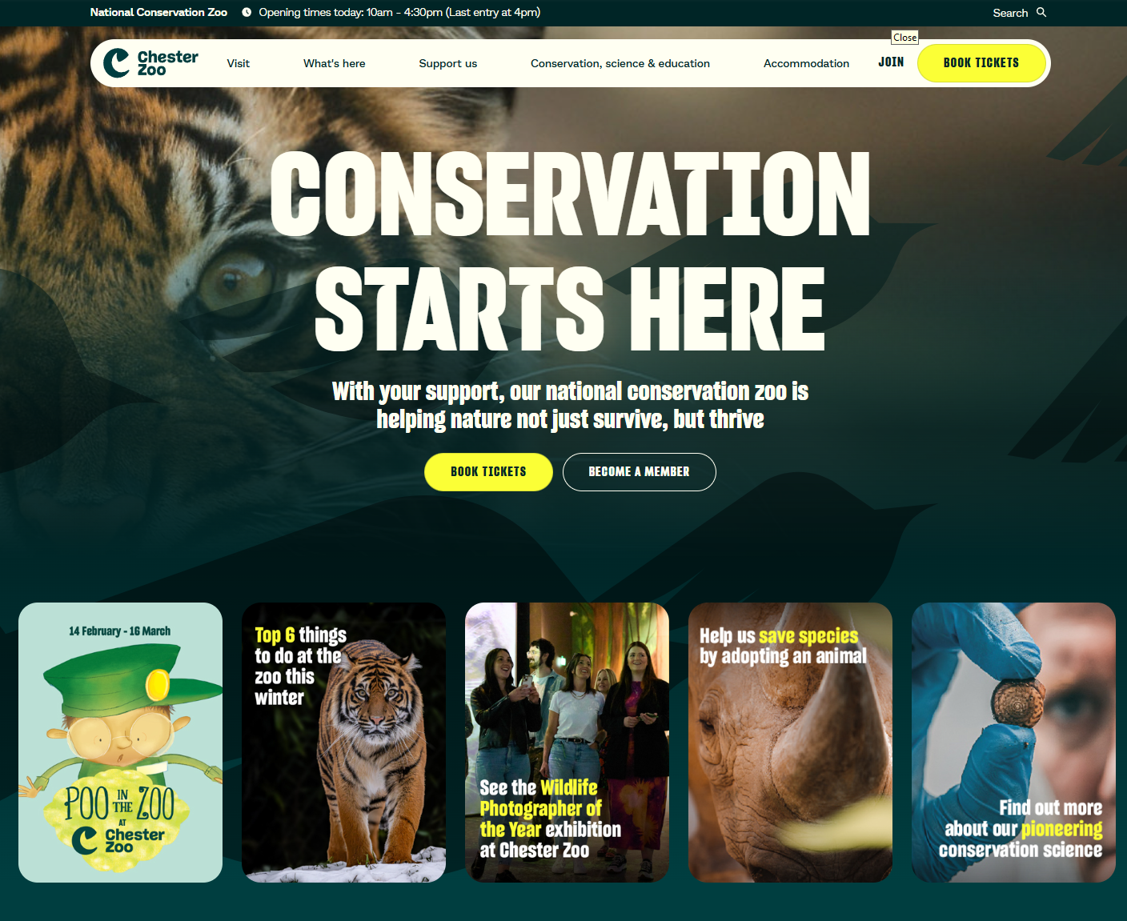

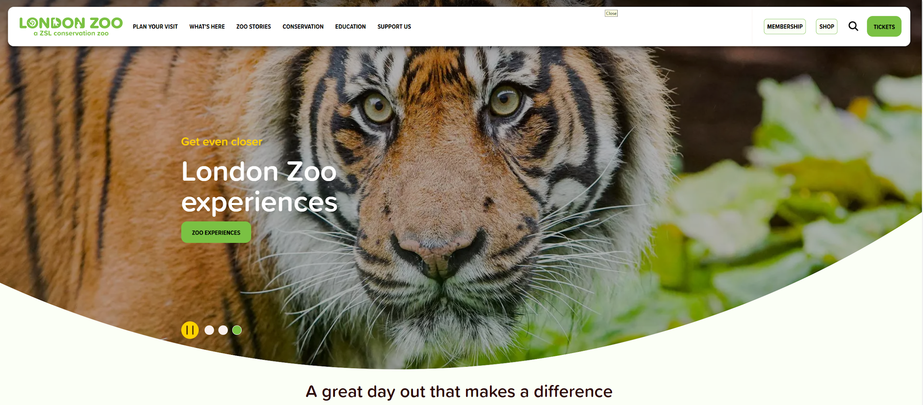

Navigation bar and options for different users:



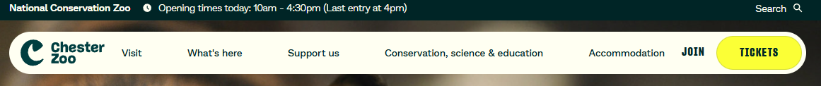

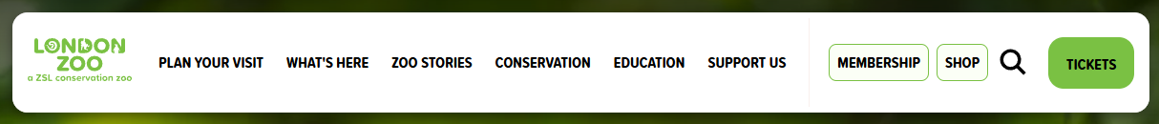

Booking tickets:

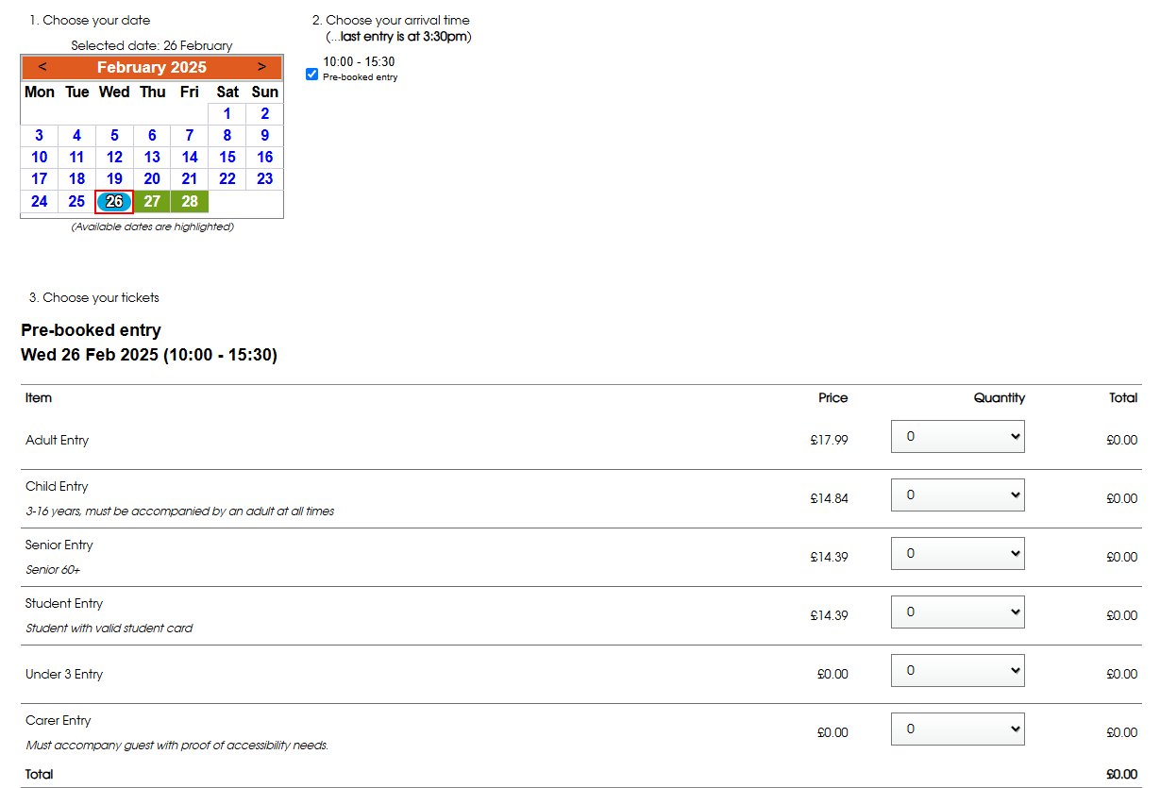

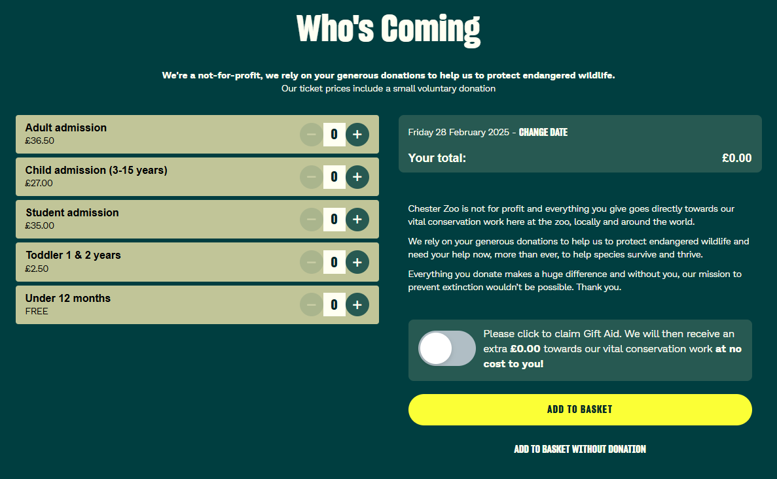

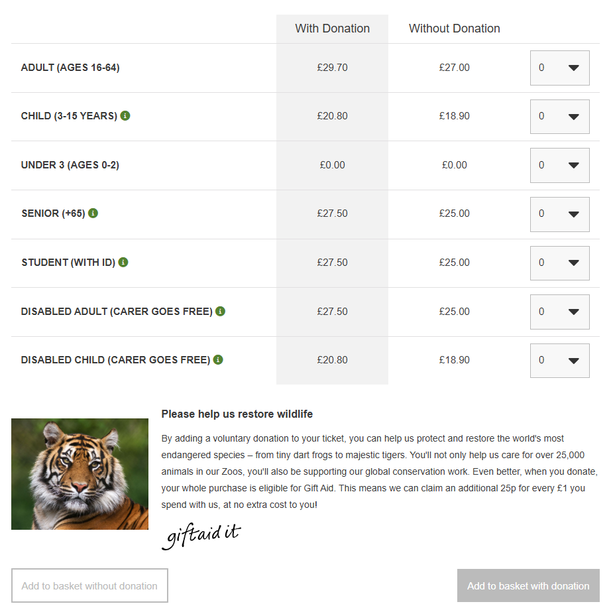

Guidelines and Regulations

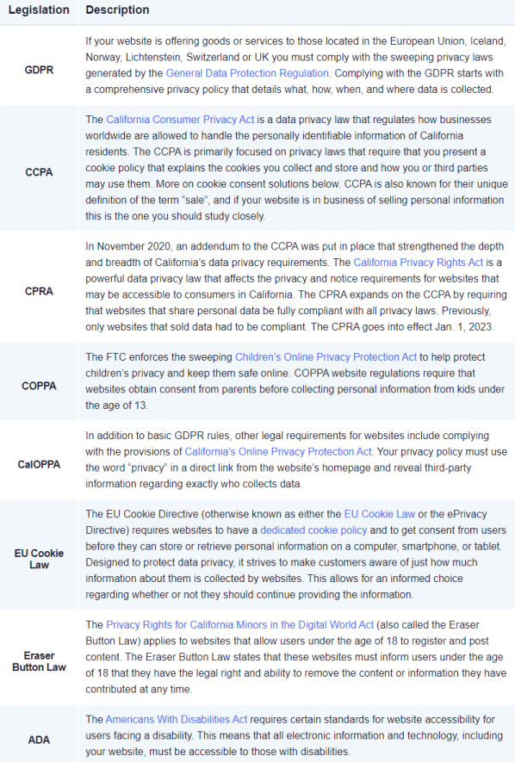

Appendix 2

Links to sources:  
<https://www.londonzoo.org/>

<https://www.chesterzoo.org/>

<https://www.marwell.org.uk/>

Task 2

Test Log:

| **Description of test** | **Test data to be used (if required)** | **Expected outcome** | **Actual outcome** | **Comments and intended actions** |
| --- | --- | --- | --- | --- |
| Verify that users can successfully register using valid credentials. | Email: [name@name.name](mailto:name@name.name)  Password:  name | New users should be able to register successfully. | Registration  completed successfully. | No issues found. Ensure continuous testing when updates are made to authentication. |
| Verify that the system handles incorrect registration inputs properly. | Email:  12345  Password:  12345 | Registration should fail with an error message explaining the issue. | Email validation error displayed correctly.  Password mismatch error displayed correctly. | Error messages are clear and displayed properly. |
| Verify that users can successfully log in using valid credentials. | Email: [name@name.name](mailto:name@name.name)  Password:  name | Existing users should be able to log in without issues. | Login with existing credentials worked as expected. | No issues found. Ensure continuous testing when updates are made to authentication. |
| Verify that the system handles incorrect log in inputs properly. | Email:  12345  Password:  12345 | Log in should fail with an error message explaining the issue. | Email validation error displayed correctly.  Password mismatch error displayed correctly. | Error messages are clear and displayed properly. |
| Ensure that the login button does not appear when a user is already logged in. | User logs in successfully | The login button should be replaced with a "Logout" button. | Login button disappeared after the login.Logout button appeared correctly. | Everything is working correctly. |
| Check if a logged-in user can access the login page. | A logged-in user manually enters example.com/login. | The user should be redirected to the dashboard instead. | The user was successfully redirected to the dashboard. | Redirection is working as expected. |
| Check if error messages appear when login credentials are incorrect. | Wrong email: [wrong@example.com](mailto:wrong@example.com)  Wrong password: IncorrectPass123 | Prompt should say: *"Invalid email or password."* | Error message displayed correctly. | The messaging system works perfectly. |
| Verify that non-logged-in users cannot access protected pages. | Access example.com/dashboard without logging in. | The system should redirect users to the login page. | Non-logged-in users were redirected to the login page. | Access control is working properly. |
| Ensure that logged-in users are redirected if they try to access the login page. | A logged-in user tries to visit example.com/login. | They should be redirected to the home page. | Logged-in users were correctly redirected to the home page. | Redirection works perfectly. |
| Ensure login and register buttons submit forms correctly. | Click "Login" and "Register" buttons after entering valid credentials. | The forms should submit, and users should be logged in or registered. | Buttons functioned correctly. | No issues found. |
| Check if clicking "Logout" properly logs out the user. | Click "Logout" after logging in. | The user should be logged out and redirected to the login page. | Logout functioned correctly. | The logout process is working fine. |
| Password Reset option | Click “Reset Password” after logging in. | The password should be resetted | The error page appears | Password Reset doesn't work as expected |

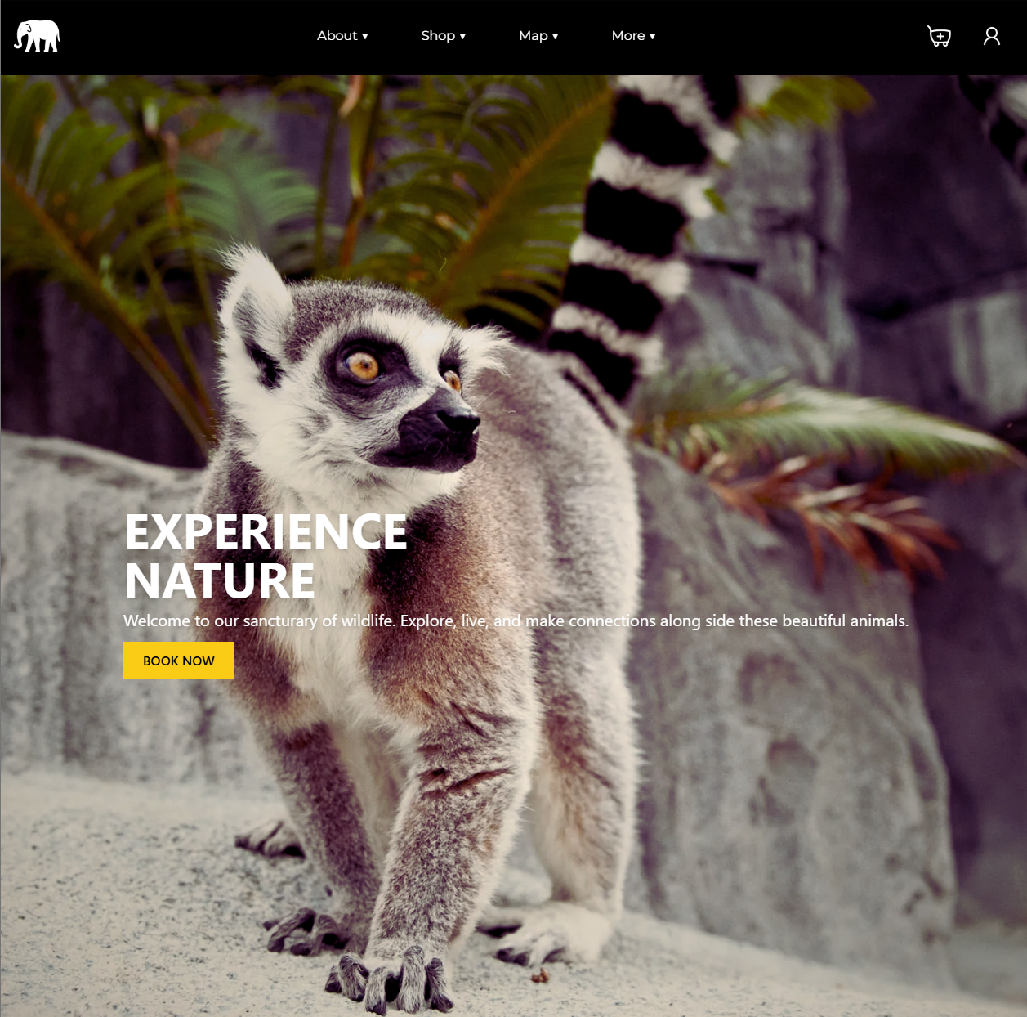

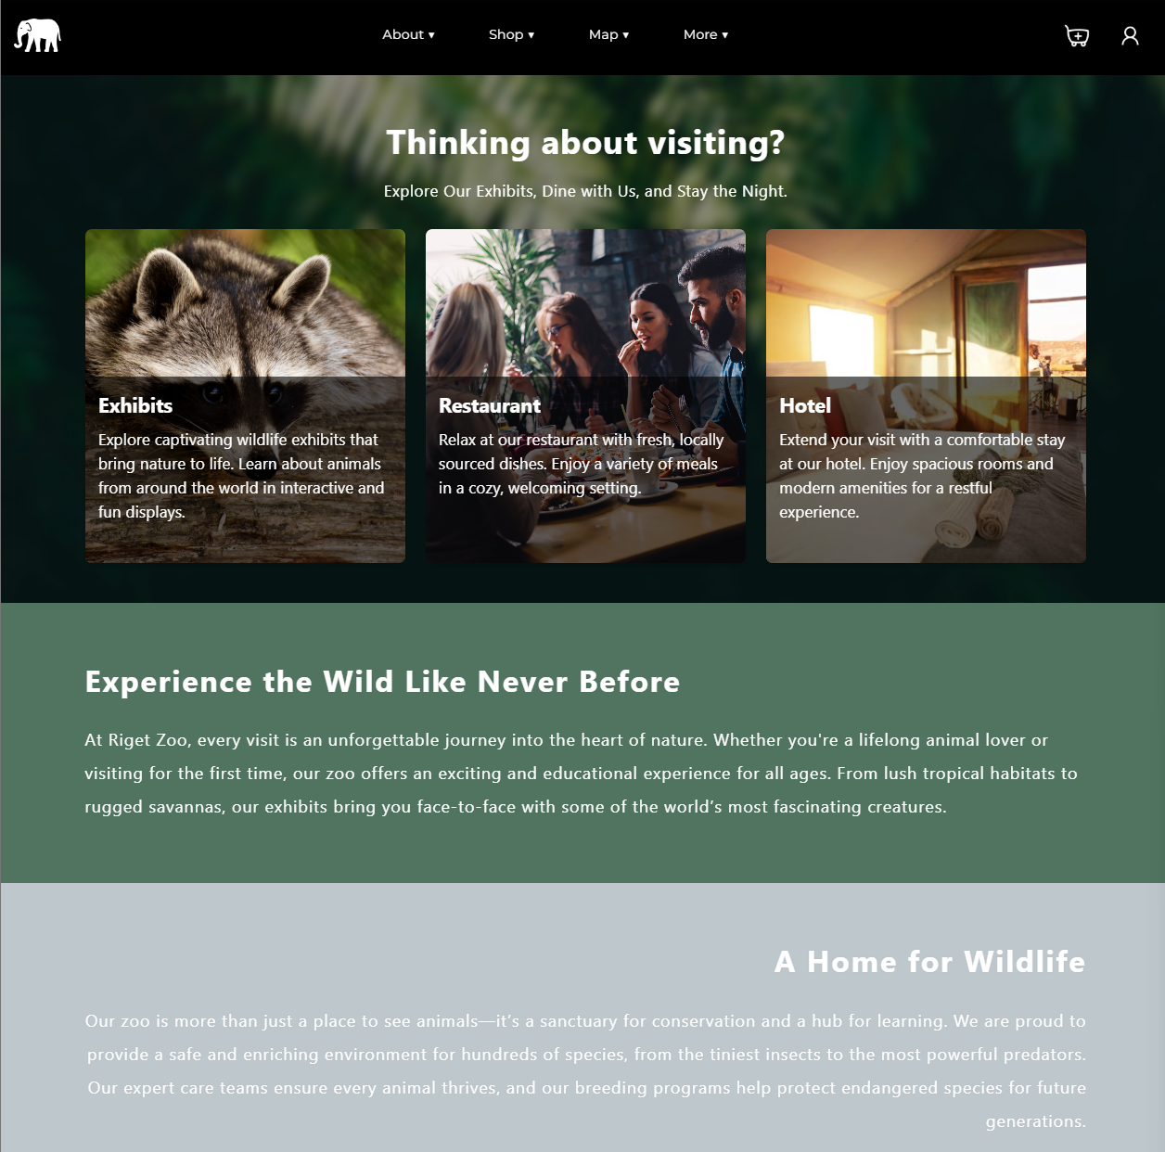

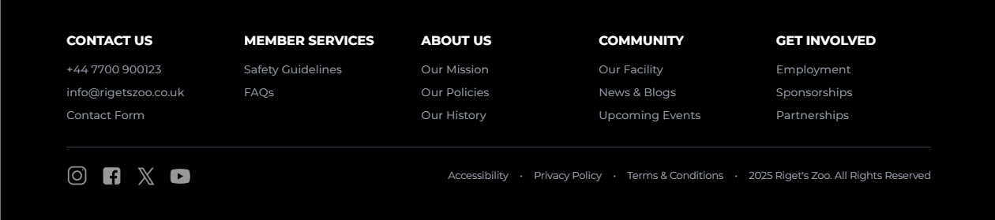

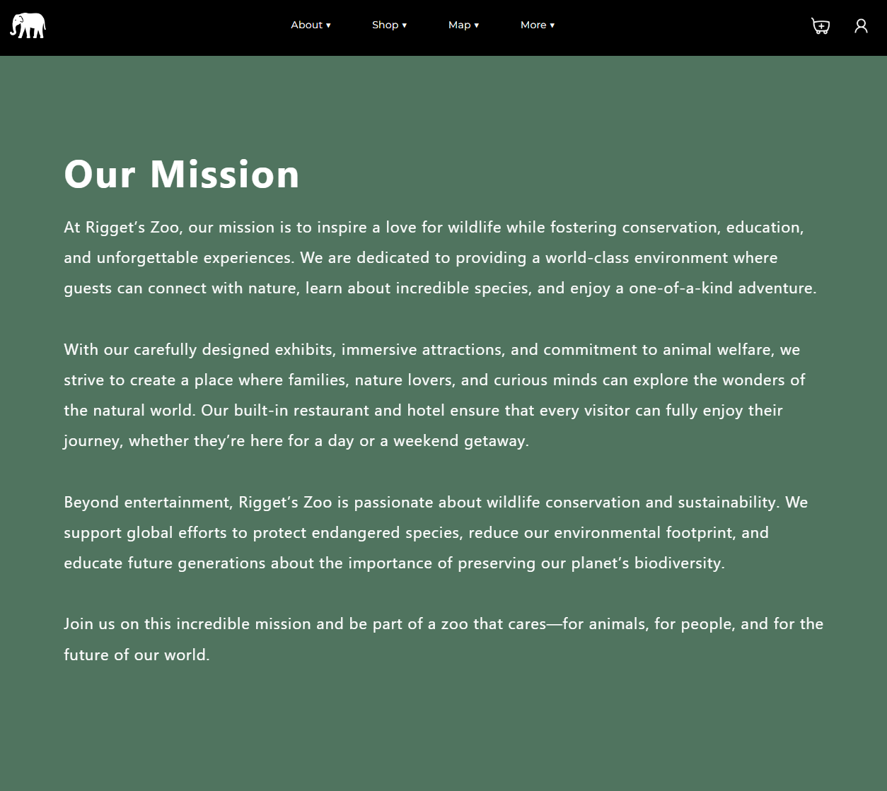

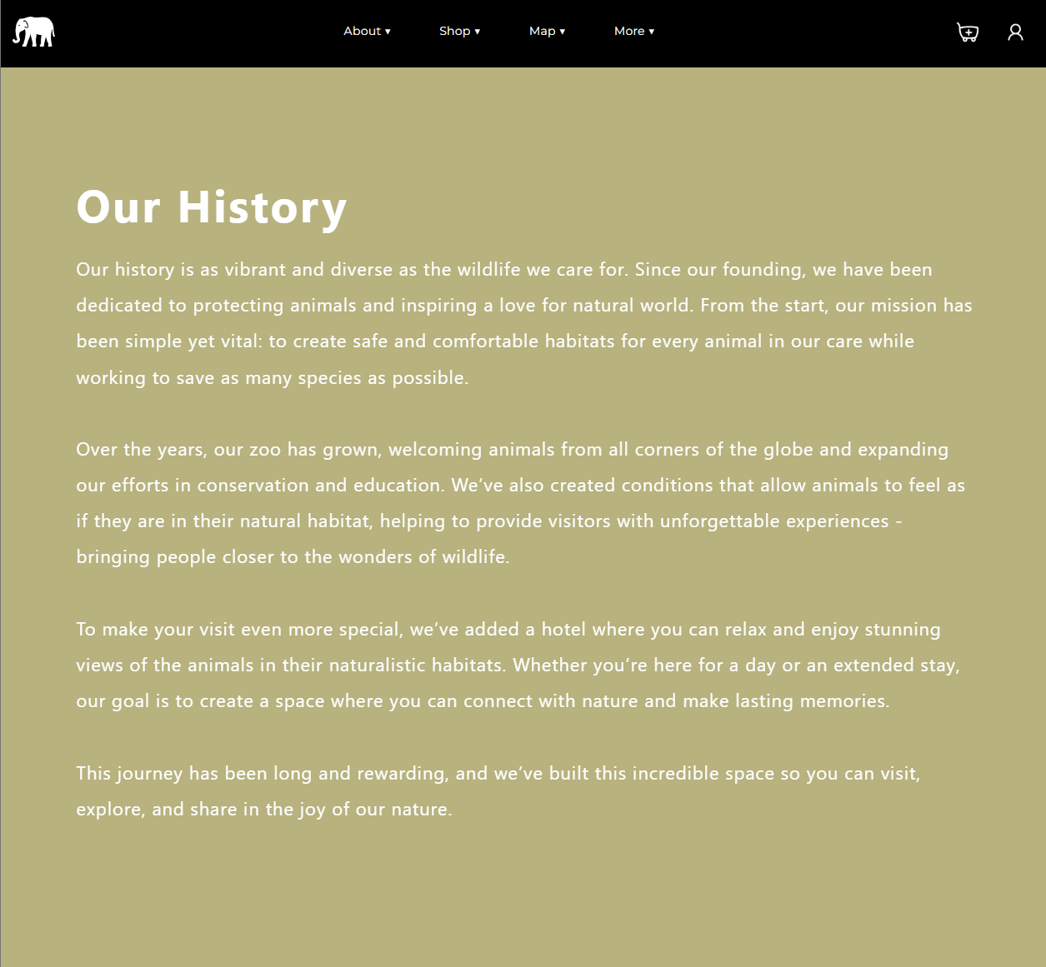

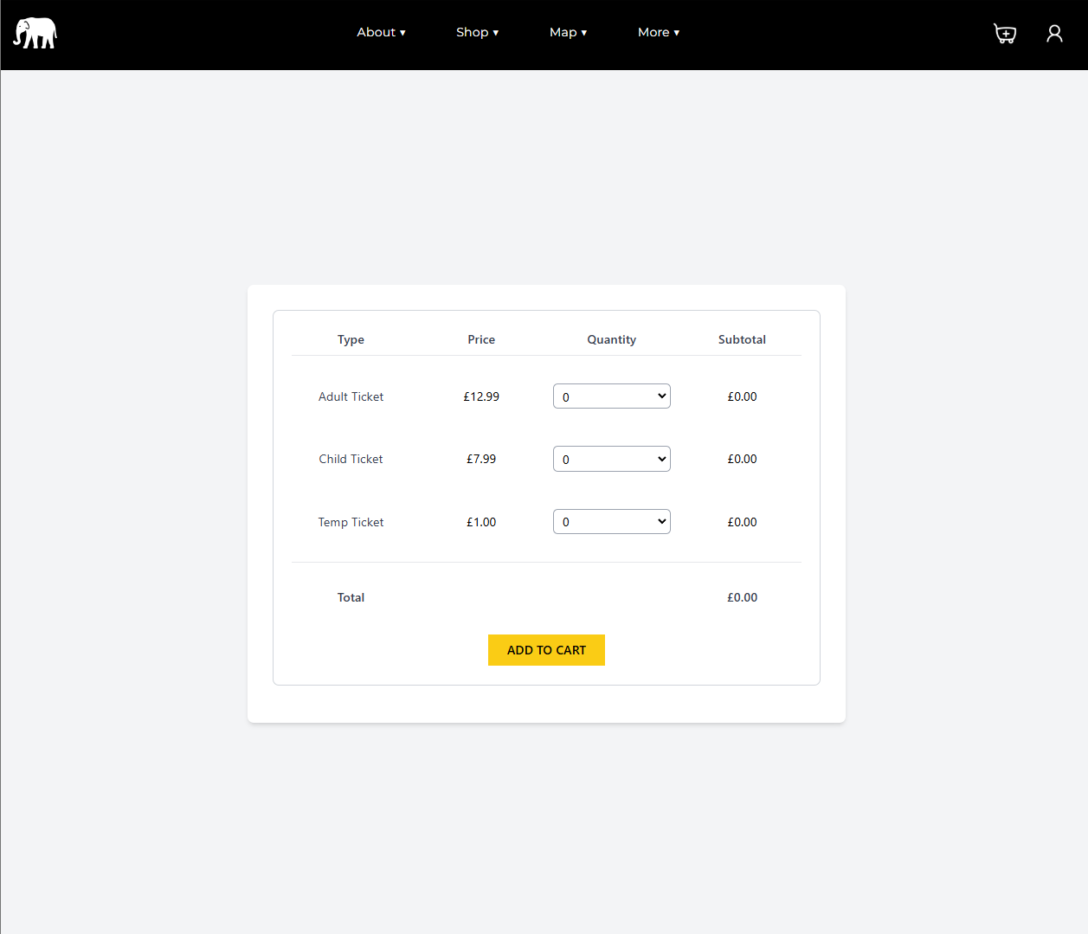

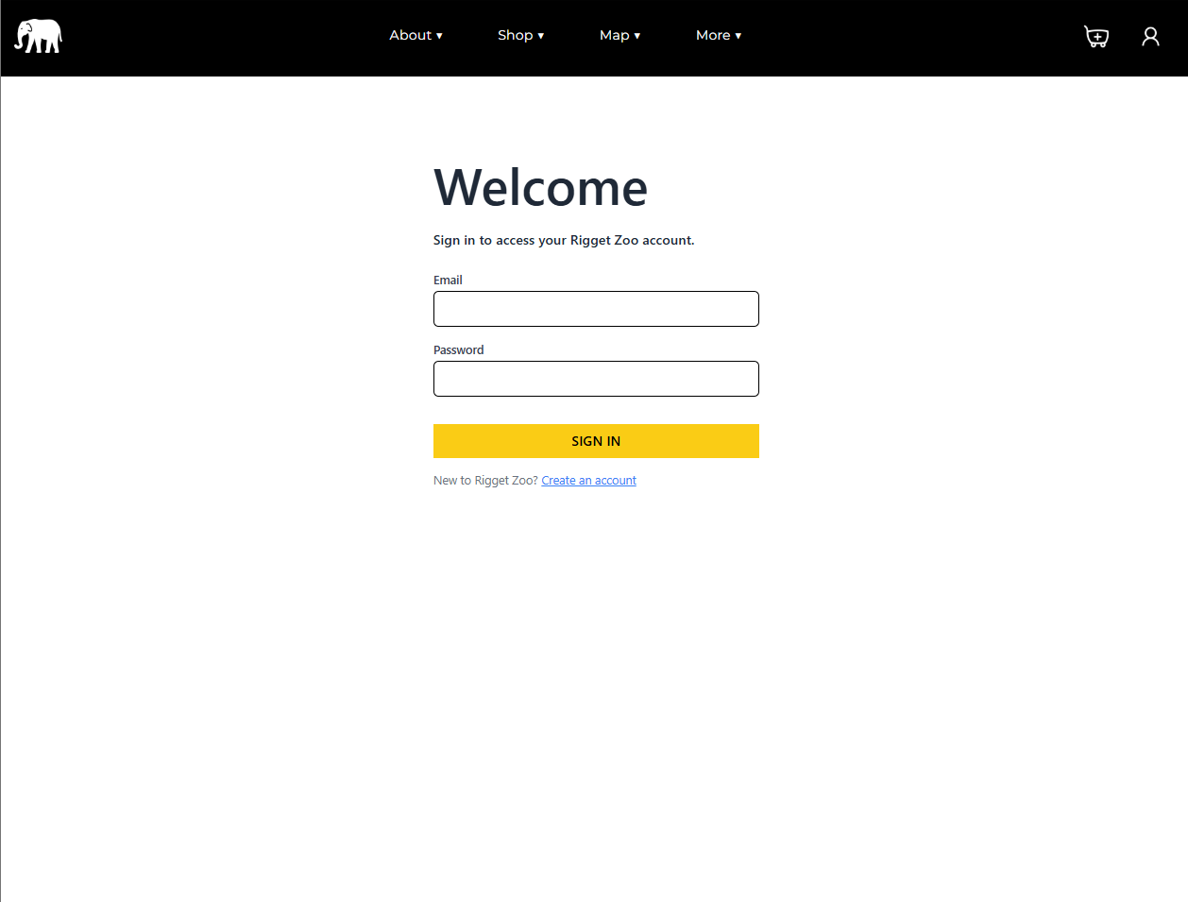

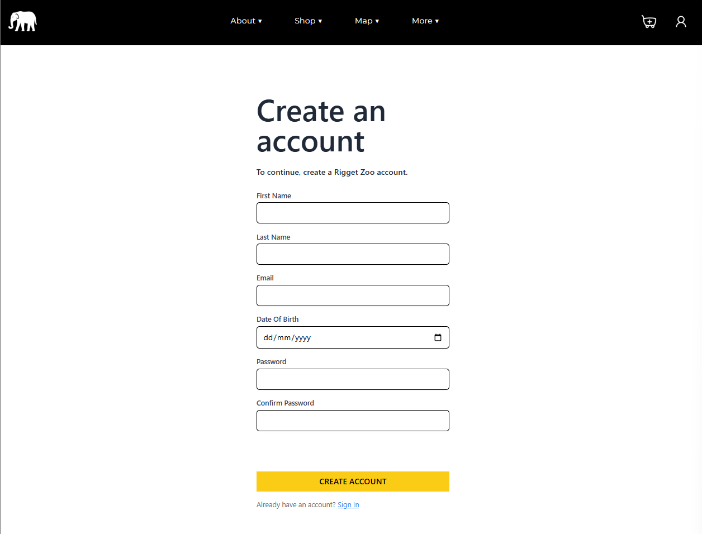

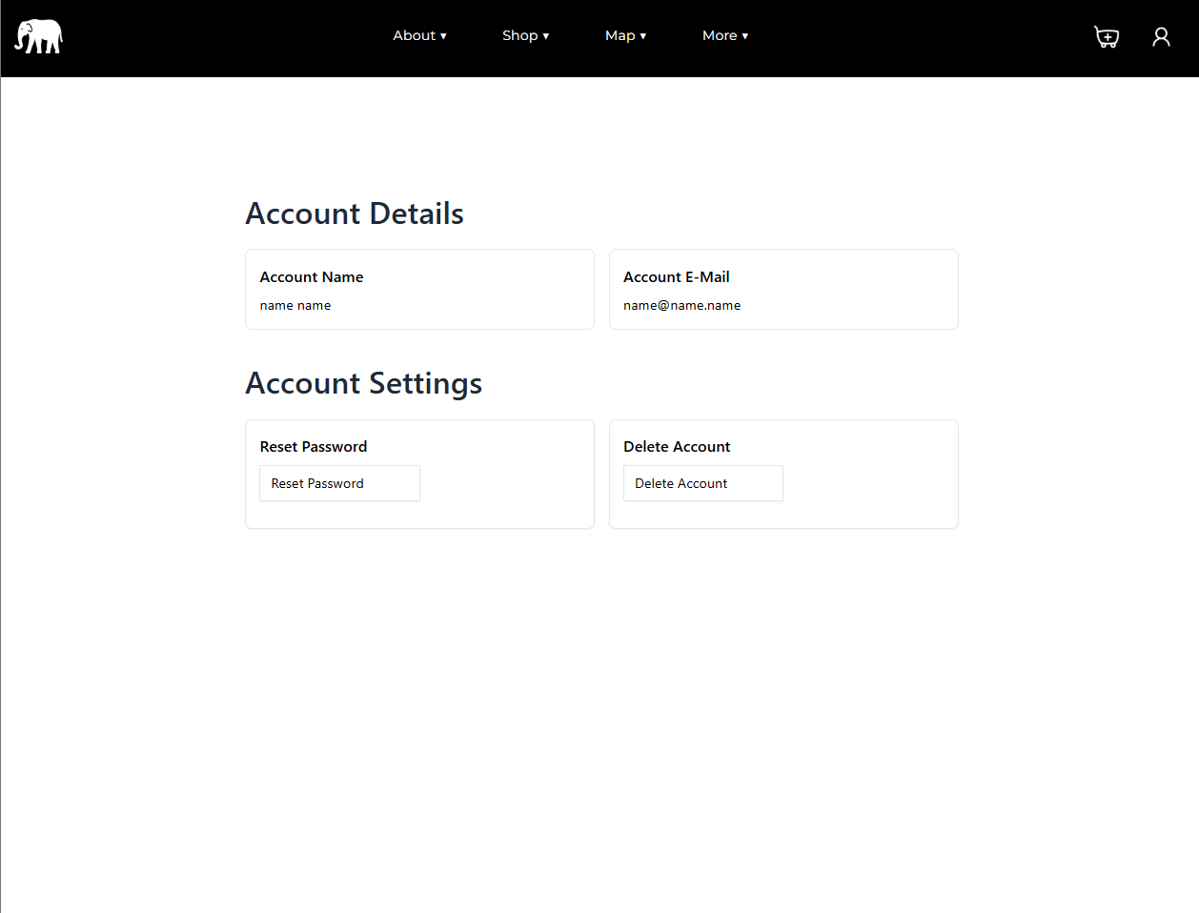

**Tech stack**

| **Type** | **Name** | **Description** |
| --- | --- | --- |
| **Back End** | **MySQL** | **A database management system, which is easily used and widely known.** |
| **Back End** | **PHP** | **A language used for making dynamic web pages and manipulating databases.** |
| **Front End** | **Javascript** | **A coding language commonly used for scripting within websites.** |
| **Front End** | **CSS** | **A language used to style elements on a web page.** |
| **Front End** | **HTML** | **A language used to layout elements on a web page.** |
| **API** | **Stripe** | **Stripe is used for collecting payments from users, or initiating subscriptions** |

**Task 3a**

***Contents***

Aim of feedback

Feedback summary

Synopsis of who was asked for feedback

Synopsis of who responded and provided feedback

Results of feedback (results, charts, graphs, scales, etc.)

Summary of feedback in detail

Overall impression

Navigation

Homepage

About page

Educational visit page

Main booking page, booking system and sign up/login system

Pure Technical questions

**Aim of feedback**

To evaluate the effectiveness of the prototype and determine how well it meets the client’s requirements, I will create a questionnaire for two user groups: technical and non-technical. The questionnaire will include targeted questions covering specific aspects of the website

**Feedback summary**

**Synopsis of who was asked for feedback**

For this questionnaire, I have carefully selected the participant for feedback. A total of 1 participant completed the form.

**Synopsis of who responded and provided feedback**

The selected participant responded to the questionnaire and provided feedback.

**Results of feedback (results, charts, graphs, scales, etc.)**

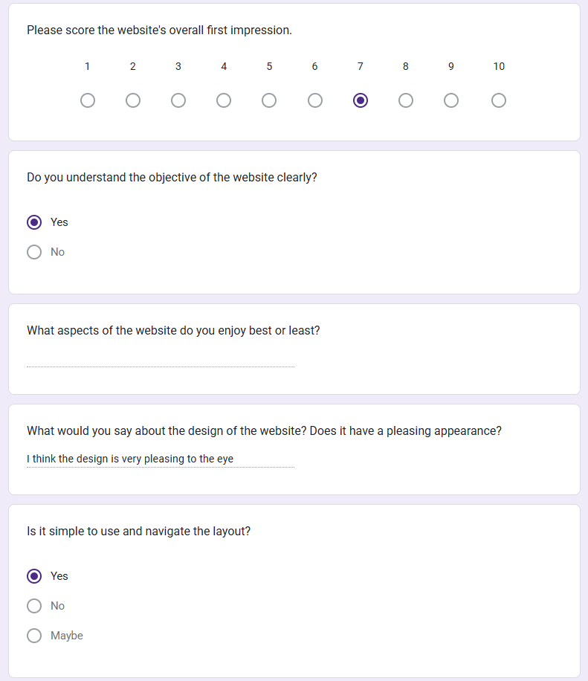

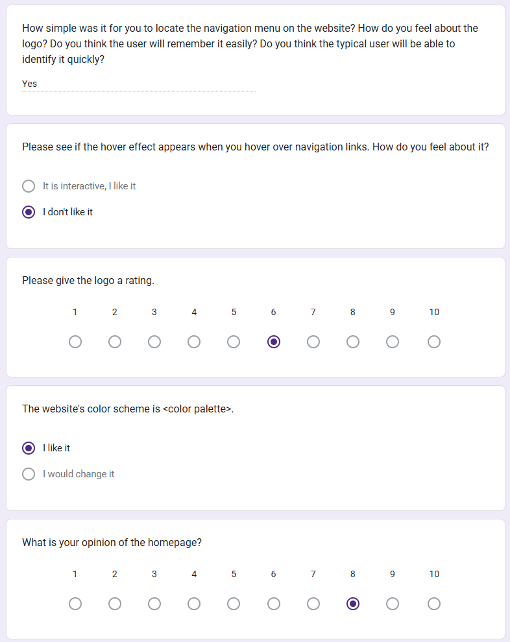

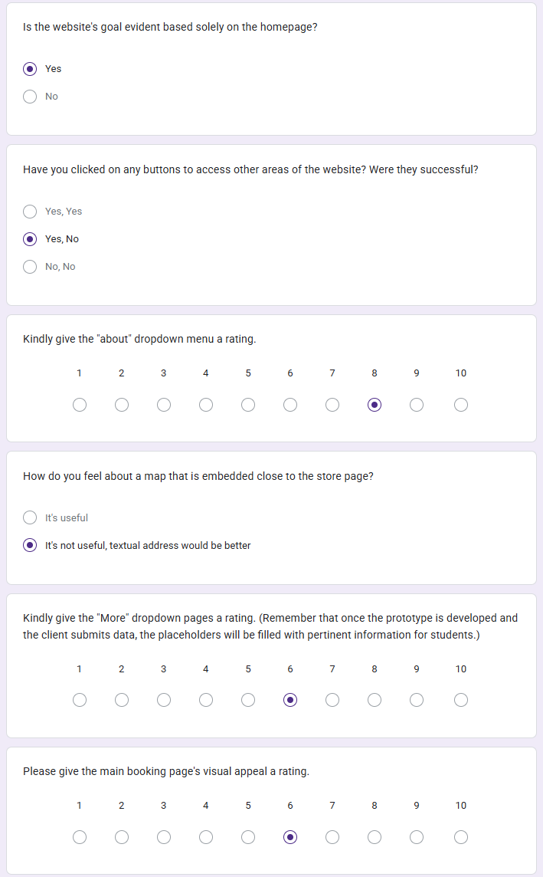

**Summary of feedback in detail**

**Overall impression**

Since I have only one response, the rating for the first impression is 7 out of 10, with the highest score being 10 and the lowest 7. I agree with this assessment, as I see potential for further frontend development.

Regarding the question about whether the objective of the website clearly, the response was yes, which I consider a success. This ensures the right audience stays engaged and helps reduce the bounce rate.

On the other hand, the footer structure was pointed out as an area for improvement. I completely agree, as I prioritized backend functionality over refining the footer. In hindsight, adding a "Still under development" message would have helped set expectations.

For the question "What would you say about the design of the website? Does it have a pleasing appearance?", the response was: "I think the design is very pleasing to the eye." which confirms that the website looks visually appealing.

**Non-technical quiz**

**Navigation**

In the questionnaire, I asked testers if the layout was intuitive and easy to navigate, and the answer is positive.

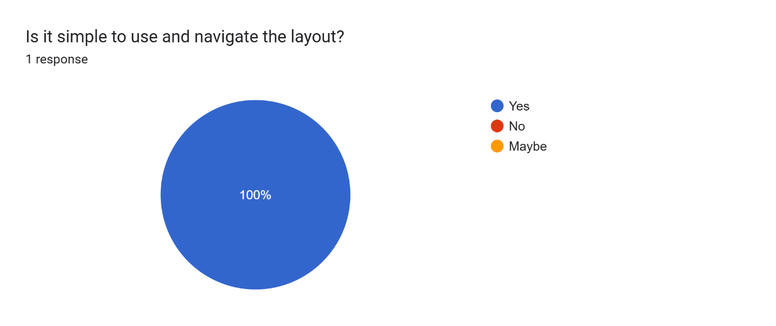

Since some users did not see the effect, this indicates a potential issue that may need fixing

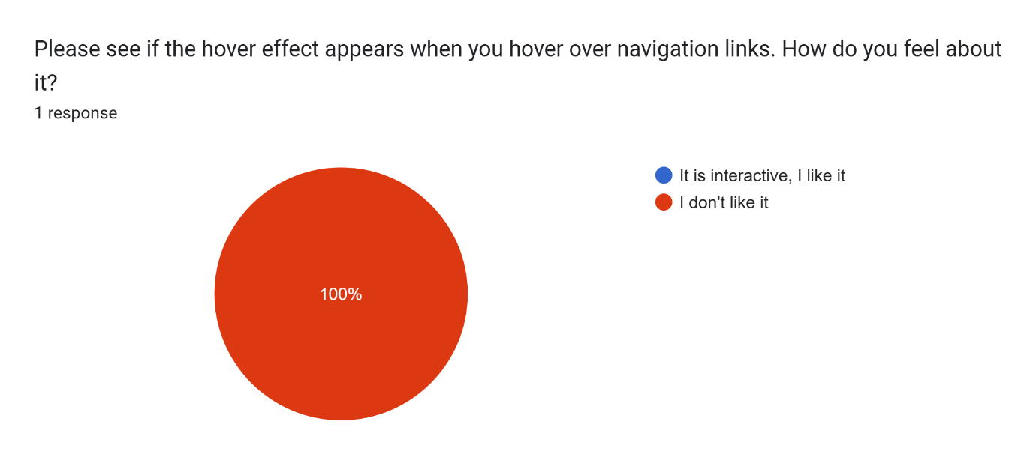

**Homepage**

I think the colour palette is really important for a website because many users base their opinion on how it looks.

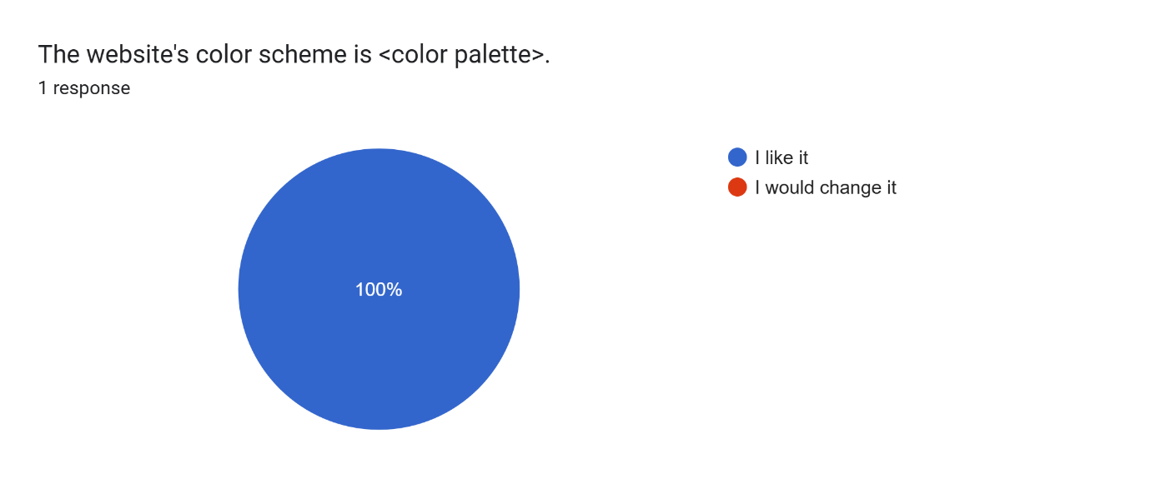

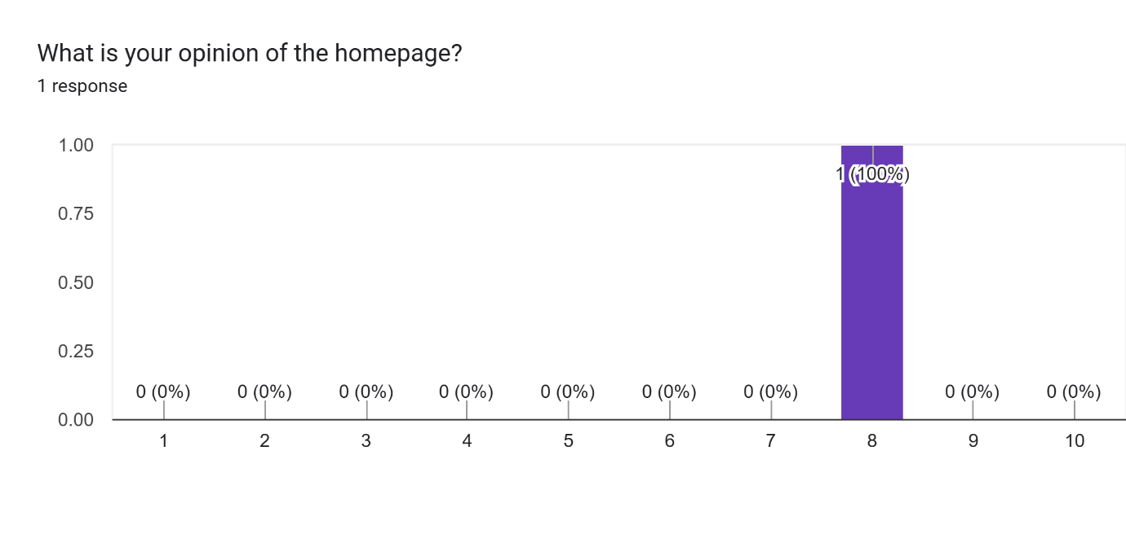

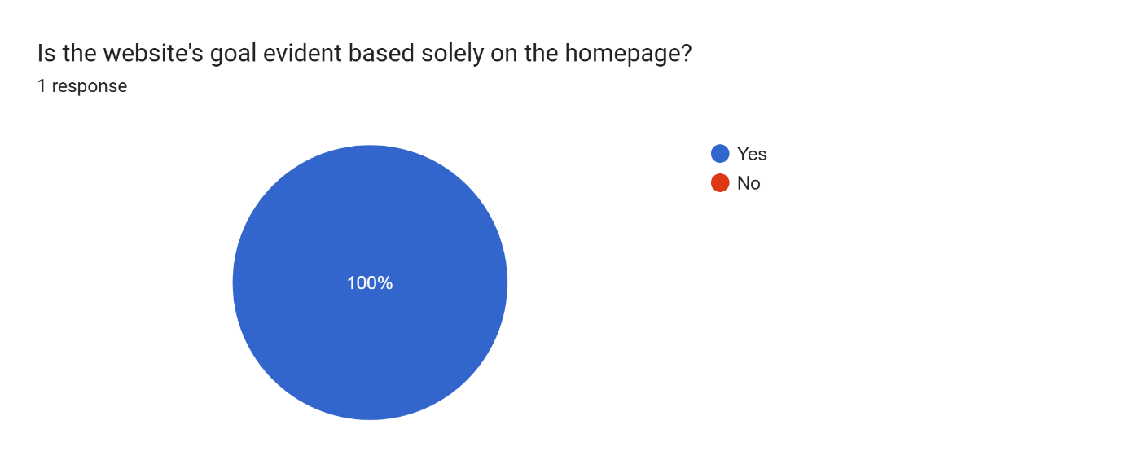

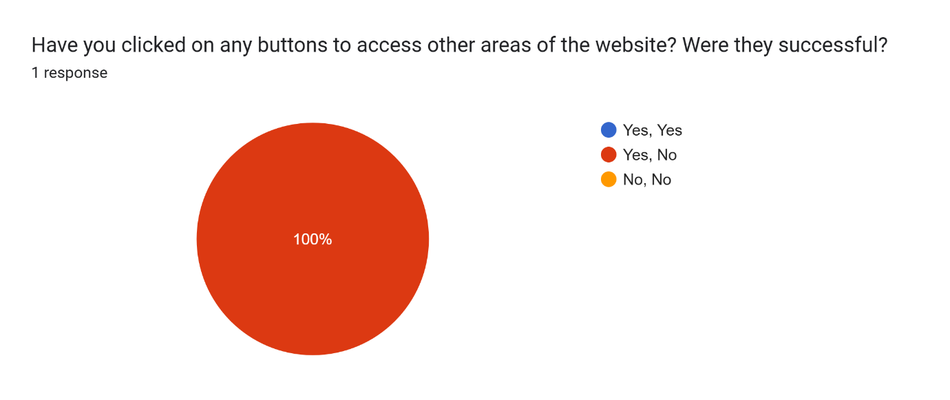

**About page**

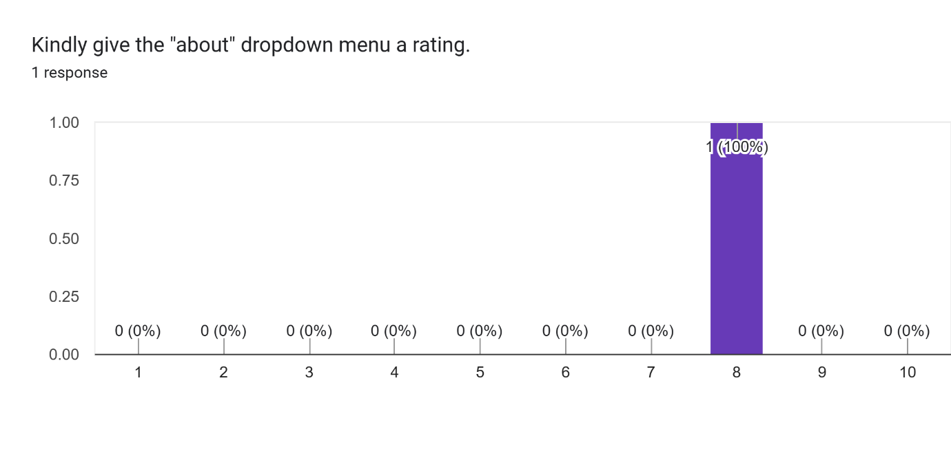

**Educational visit page**



**Main booking page, booking system and sign up/login system**

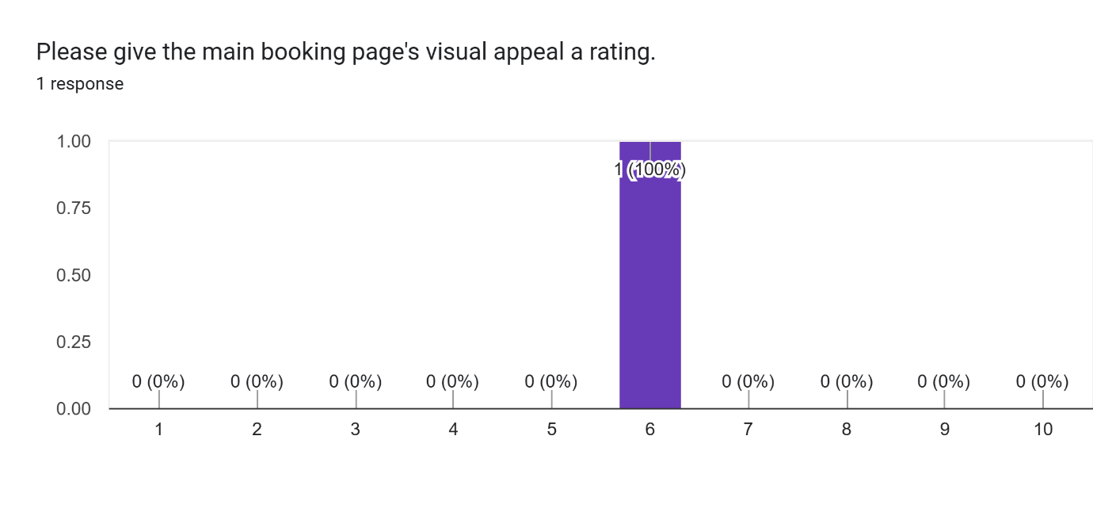**Pure Technical questions**

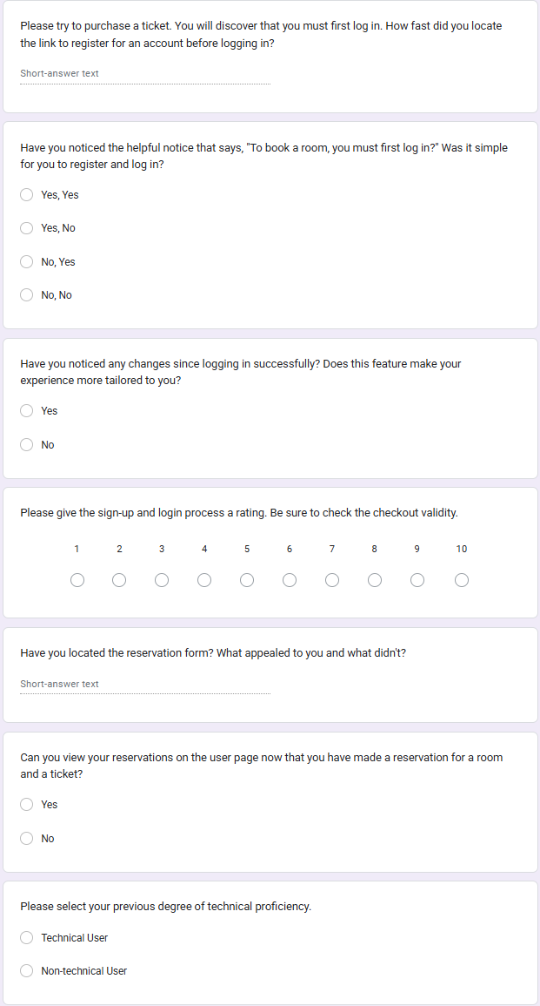

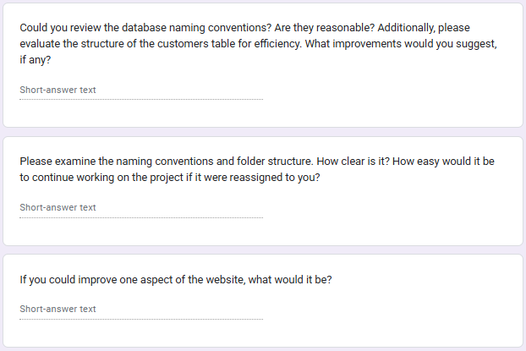

1. **Please try to purchase a ticket. You will discover that you must first log in. How fast did you locate the link to register for an account before logging in?**  
   The "Register" link was easy to find; it took me about 5 seconds to locate it near the login section.
2. **Have you noticed the helpful notice that says, "To book a room, you must first log in?" Was it simple for you to register and log in?**  
   Yes
3. **Have you noticed any changes since logging in successfully? Does this feature make your experience more tailored to you?**  
   Yes
4. **Please give the sign-up and login process a rating. Be sure to check the checkout validity.**  
   I would rate the sign-up and login process an 8/10. The process was smooth, but the checkout validation could be improved.
5. **Have you located the reservation form? What appealed to you and what didn't?**  
   Yes
6. **Can you view your reservations on the user page now that you have made a reservation for a room and a ticket?**  
   Yes
7. **Please select your previous degree of technical proficiency.**  
   Technical user.
8. **Could you review the database naming conventions? Are they reasonable? Additionally, please evaluate the structure of the customers table for efficiency. What improvements would you suggest, if any?**  
   The database naming conventions seem reasonable, but some table names could be more descriptive. The customers table structure is generally efficient, though indexing frequently searched fields could improve performance.
9. **Please examine the naming conventions and folder structure. How clear is it? How easy would it be to continue working on the project if it were reassigned to you?**  
   The naming conventions and folder structure are mostly clear. If the project were reassigned, I believe it would be fairly easy to continue working, but additional documentation would help.
10. **If you could improve one aspect of the website, what would it be?**  
    I would improve the overall UI/UX by making the design more modern and enhancing mobile responsiveness.

Depending on user responses, the website provides a positive experience with easy navigation and a well colour palette.

The hover effect needs adjustments, and some improvements in the database structure are recommended.

***Task 3b***

**Introduction**

In this passage I will be evaluating the effectiveness of the digital solution that I’ve been developing during this assessment period and how it meets requirements. As well as that I will be sharing my ideas as to how the solution can be developed further.

**The Effectiveness of the assets and content used**

The reasoning behind selection

Most of the assets on the website were chosen in the design stage and then implemented during development. I have carefully chosen all of them, to make sure they are a good representation of my client - RZA adventures.

**Testers Feedback**

The Website was tested, the feedback was analysed, and action taken to enhance the customers' experience. Testers liked the option to easily navigate between pages using the well-structured navigation bar. The homepage was found to be visually appealing and user-friendly, with clearly labelled buttons that functioned as expected. In particular, testers appreciated the booking system and ticket purchases, by making a note that it was intuitive and easy to use.

**Compliance and Social Media Integration**

All external links considered copyright, intellectual property, and licensing requirements. The website is also linked to social media, encouraging visitors to use more services provided by the zoo and access additional information and advice about animal conservation and zoo activities.

**Meeting Requirements and Performance**

I believe that the majority of the functional and non-functional requirements of the system and legal requirements were met. The website provides customised information and advice about animal conservation and zoo activities to help visitors enhance their experience. Overall, the website performed well; the system was responsive, and user navigation worked smoothly.

**Proposed Solution and Future Improvements**

My proposed solution provides the zoo with a professional and easy-to-use system that promotes their services and encourages visitors to use it. Potential future improvements identified during development and testing include adding more types of activities to the list. Testers reported the need to select various common activities that were not available, as password reset.

**Web Interface Usage**

On accessing the website, the user lands on the homepage. The user can access the website under two different profile categories: a visitor or a registered user. The homepage contains a navigation bar at the top that allows easy access to different sections of the website. As a visitor, the user can access the following sections through the dropdowns:

**About**:

Missions

Policies

History

Safety guidelines

FAQ

**Shop**:

Zoo Bookings

Hotel Bookings

Gift Shop

Restaurant

**Map**:

Zoo Layout

Hotel Layout

**More**:

News and Blogs

Upcoming events

Employment opportunities

Sponsorships

Partnerships

**Unfinished features**

There are some issues that couldn't be addressed due to lack of time, such as implementing a password reset feature, a shopping cart for purchasing zoo merchandise, a blog system, an upcoming events system, and integration with the gift shop and restaurant. These features require more development and testing to ensure they work correctly and securely. However, the overall system provides a solid foundation for future enhancements and continued improvement.